Medical Store Management System
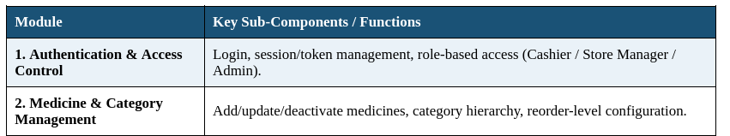

VEDANTIKA MAHADIK:-LOGIN PAGE AND AUTHENTICATION DONE
SHREYA SHIVADE:-LOGIN PAGE AND ACCESS CONTROL DONE
SUMIT BHAMARE:-PENDING (DATABASE)

Flow Chart for Login Activities :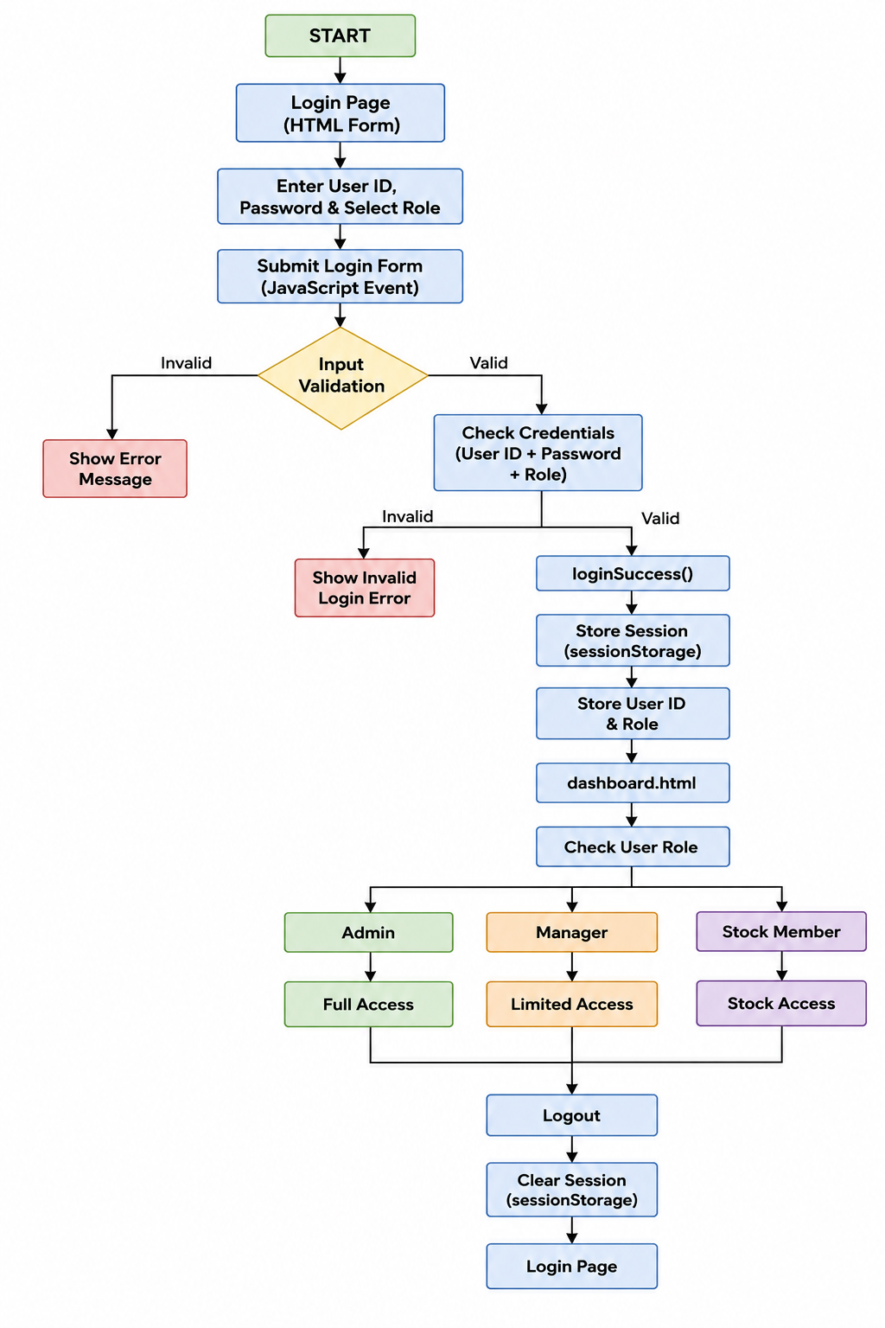s :

